Project Number: 700085

Project Acronym: ARIES

Project title: Reliable European Identity Ecosystem

Periodic Technical Report

Part B

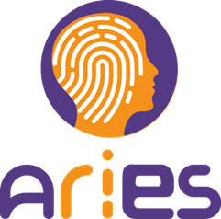

Period covered by the report: from 01/03/2018 to 28/02/2019
Periodic report: 2nd

Document History

Version | Date | Author(s) | Description/Comments
0.1 | 06/03/2019 | Sara Diez | ToC

Contents
1 Explanation of the work carried out by the beneficiaries and Overview of the project 4
1.1 Objectives ATOS 4
1.2 Explanation of the work carried out per work package 5
1.2.1 WP1 - Ethics requirements 5
1.2.2 WP2 - Procedural, ethical, legal & societal requirements for ID ecosystem UMU 5
1.2.3 WP3 - Strengthening the technology for ID GEMALTO 6
1.2.4 WP4 - Demonstrators Integration and Evaluation POCC 7
1.2.5 WP5 - Design, Communication and Exploitation of ecosystem for identity services ATOS 8
1.2.6 WP6 - Dissemination and Standardisation UMU 9
1.2.7 WP7 - Project and Innovation Management ATOS 9
1.3 Impact ATOS 11
2 Update of the plan for exploitation and dissemination of result (if applicable) ATOS UMU 12
3 Follow-up of recommendations and comments from previous review ATOS 13
4 Deviations from Annex 1 ATOS 14
4.1 Tasks 14
4.2 Use of resources ALL 15
5 Periodic Financial Report ALL 16

List of tables
Table 1 - Partners activities WP2 6
Table 2 - Partners activities WP3 7
Table 3 - Partners activities WP4 8
Table 4 - Partners activities WP5 8
Table 5 - Partners activities WP6 9
Table 6 - Partners activities WP7 10
Table 7 - ARIES impact 11

Explanation of the work carried out by the beneficiaries and Overview of the project

Objectives ATOS

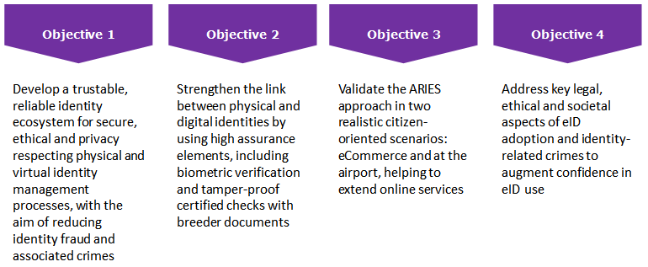
Figure 1- ARIES objectives

Objective 1: Develop a trustable, reliable identity ecosystem for secure, ethical and privacy respecting physical and virtual identity management processes, with the aim of reducing identity fraud and associated crimes
Objective 2: Strengthen the link between physical and digital identities by using high assurance elements, including biometric verification and tamper-proof certified checks with breeder documents.
Objective 3: Validate the ARIES approach in two realistic citizen-oriented scenarios: eCommerce and at the airport.
Objective 4: Address key legal, ethical and societal aspects of eID adoption and identity-related crimes to augment confidence in eID use

Explanation of the work carried out per work package

WP1 - Ethics requirements
Work package completed in the first reporting period

D1.1: GEN - Requirement No. 1 [3]

D1.2: GEN - Requirement No. 2 [3]

Work carried out by each beneficiary

ATOS
UMU
SAHER

WP2 - Procedural, ethical, legal & societal requirements for ID ecosystem UMU

T2.1 Functional requirements for ID ecosystem

T2.2 Societal and Ethics Evaluation of ID and threats

T2.3 Legal requirements and impact on law enforcement

T2.4 - Privacy and data protection compliance

Work carried out by each beneficiary

ATOS
UMU
GTO
IDEMIA
SAHER
POCC
ERTZ
BFP
SONAE | Update of the business and technical requirements and development of new requirements for the Voice Authentication & Login. Update and validation of the ethical requirements for the demonstrators.
Table 1 - Partners activities WP2

WP3 - Strengthening the technology for ID GEMALTO

Task 3.1 - Definition for the system architecture

Task 3.2 - Virtual identity developments

Task 3.3: Enrolment and authentication tools for ICAO-compliant face acquisition and liveness detection

Task 3.4 - Platform integration and API specification

Work carried out by each beneficiary

ATOS
UMU
GTO
IDEMIA
Saher
Table 2 - Partners activities WP3

WP4 - Demonstrators Integration and Evaluation POCC

Task 4.1 - Demonstration Setup UMU

Task 4.2 - Prototype Demonstration and Evaluation Plan SAHER, UMU

Task 4.3 - Secure eCommerce prototype demonstrator SONAE
The secure e-Commerce demonstrators focused on demonstrating how virtual identities with different levels of assurance can be used to access different online services. The demonstration setup was fully implemented by using biometrics, such as the Face recognition. Later in the process in 2018 the Voice recognition demonstrator was delivered. End users were engaged, and their feedback collected, making sure an ethical assessment was done and the ethical management methodology designed in the project was applied.
All results were evaluated and presented in a systematized way to allow for relevant follow up within the project and the after-project scope. Full detail can be read in deliverable D4.3 – Secure eCommerce Prototype Demonstrator. Finally, a Hand’s-On Workshop for future Technological Adoption was organized at Sonae in February 2019 with the participation of end-users, project partners and other stakeholders.

Task 4.4 - Identity virtualization prototype demonstrator POCC

Task 4.5 - Evaluation and Validation GEMALTO

Work carried out by each beneficiary

ATOS
UMU
GTO
IDEMIA
SAHER
POCC
ERTZ
SONAE | Sonae led Task 4.3 - Secure eCommerce prototype demonstrator, where it managed to accompany integrations of the Face and Voice demonstrators and experiment with end-users, in Usability Acceptance Testing and other validations of the application of the technology.
Table 3 - Partners activities WP4

WP5 - Design, Communication and Exploitation of ecosystem for identity services ATOS

Task 5.1 - Sustainability design of ecosystem of identity services

Task 5.2 - Exploitation Plan and Report

Task 5.3 - Communication activities & Public Web Presence

Work carried out by each beneficiary

ATOS
UMU
GTO
IDEMIA
SAHER
POCC
ERTZ | .
SONAE | Sonae managed the development of a white Paper with the project results. Sonae organized a “Hand’s-on Workshop” for dissemination project results with relevant stakeholders. Sonae contributed to the exploitation plan.
Table 4 - Partners activities WP5

WP6 - Dissemination and Standardisation UMU

Task 6.1 - Engaging scientific and technical community: Dissemination

Task 6.2 – Standardisation

Task 6.3 - ARIES Project Advisory Board

Work carried out by each beneficiary

ATOS
UMU
GTO
IDEMIA
SAHER
POCC
SONAE  (Tiago: I’ve added our input) | Sonae contributed to relevant dissemination formats, such as articles and a book chapter.
Table 5 - Partners activities WP6

WP7 - Project and Innovation Management ATOS

Task 7.1 - Project Steering

Task 7.2 - Innovation Management

Task 7.3 - Quality Assurance

Task 7.4 - Project reporting

Task 7.5 - Social Knowledge Management System (SKMS) & Internal communication

Work carried out by each beneficiary

ATOS
UMU
GTO
IDEMIA
SAHER
POCC
ERTZ
BFP
SONAE | Sonae was involved in the different project reporting, including daily management and periodical reports. Sonae participated in all necessary meetings (remote or in person, including GA’s). Sonae was also fulfilled its duties as reviewer for deliverables.
Table 6 - Partners activities WP7

Impact ATOS

Expected impacts | ARIES contributions | Relevant outcomes
Create a decisive competitive advantage for Europe on the global level
New technologies and processes in identity management will ease the work of border management and law enforcement authorities as the identity verification becomes more reliable.
The personal security increases due to reduced risk of identity fraud and cyber mobbing. Improved id documents will make people trafficking and organized crime more difficult
Make use of existing research results in this field to the highest possible extent to optimize funding impact
Developments are expected to reach TRL 4
Table 7 - ARIES impact

Update of the plan for exploitation and dissemination of result (if applicable) ATOS UMU

Follow-up of recommendations and comments from previous review ATOS

Deviations from Annex 1 ATOS

Tasks

Use of resources ALL

Every partner must provide information about the PMs spent per WP during the period by 20th March

Periodic Financial Report ALL
Estimated use of resources by 20th March

